SMSNinja blueprint
By Yinglu Zou

Database and Settings
- Database
Usage: Stores the specific configurations of each address
Location: /var/mobile/Library/SMSNinja/smsninja.db
- blacklist:
keyword: Primary key, address or keyword or time
type: 0 for address, 1 for keyword, 2 for time
name: Name
phone: 0 for off, 1 for disconnect, 2 for ignore
sms: 0 for off, 1 for block
reply: 0 for off, 1 for on
message: Reply message
forward: 0 for off, 1 for on
number: Forward number
sound: 0 for off, 1 for on
- whitelist:
keyword: Primary key, address or keyword
type: 0 for address, 1 for keyword
name: Name
phone: Reserved, to unify SQLite queries
sms: Reserved
reply: Reserved
message: Reserved
forward: Reserved
number: Reserved
sound: Reserved
- privatelist:
keyword: Primary key, address or keyword
type: 0 for address, 1 for keyword
name: Name
phone: 0 for off, 1 for disconnect, 2 for ignore, 3 for let go
sms: 0 for off, 1 for block
reply: 0 for off, 1 for on
message: Reply message
forward: 0 for off, 1 for on
number: Forward number
sound: 0 for off, 1 for on
- blockedcall:
id: Primary key
content: 0 for incoming, 1 for outgoing
name: Name
number: Number
time: Time
pictures: Reserved, to unify SQLite queries
read: 0 for unread, 1 for read
- privatecall:
id: Primary key
content: 0 for incoming, 1 for outgoing
name: Name
number: Number
time: Time
pictures: Reserved, to unify SQLite queries
read: Reserved, to unify SQLite queries
- blockedsms:
id: Primary key
content: Message body
name: Name
number: Address
time: Time
pictures: Number of attached pictures
read: 0 for unread, 1 for read
- privatesms:
id: Primary key
content: Message body
name: Name
number: Address
time: Time
pictures: Number of attached pictures
read: Reserved, to unify SQLite queries
- Settings
Usage: SMSNinja’s general configuration.
Location: /var/mobile/Library/SMSNinja/smsninja.plist
- appIsOn: SMSNinja on/off
- shouldShowBadge: Blocked calls, messages numbers badge
- shouldClearSpam: Delete blocked calls history
- startPassword: startPassword
- shouldIncludeContactsInWhitelist: Treat contacts as whitelist
- whitelistCallsOnlyWithoutBeep: whitelistCallsOnlyWithoutBeep
- whitelistCallsOnlyWithBeep: whitelistCallsOnlyWithBeep
- whitelistMessagesOnlyWithoutBeep: whitelistMessagesOnlyWithoutBeep
- whitelistMessagesOnlyWithBeep: whitelistMessagesOnlyWithBeep
- fakePassword: fakePassword
- shouldShowColon: Show colon instead of comma in badge string when there’s unread private info
- shouldShowYellowSquare: Show a yellow square when there’s unread private info
- Pictures
Usage: Stores the blocked MMSes & iMessages’ attached pictures
Location: /var/mobile/Library/SMSNinja/Pictures/
Name: id-number.ext, e.g. 1-0.jpg, 2-1.png, etc.
- PrivatePictures
Usage: Stores the private MMSes & iMessages’ attached pictures
Location: /var/mobile/Library/SMSNinja/PrivatePictures/
Name: id-number.ext, e.g. 1-0.jpg, 2-1.png, etc.

Overall User Interfaces and Variables
- RootViewController
- UI draft:
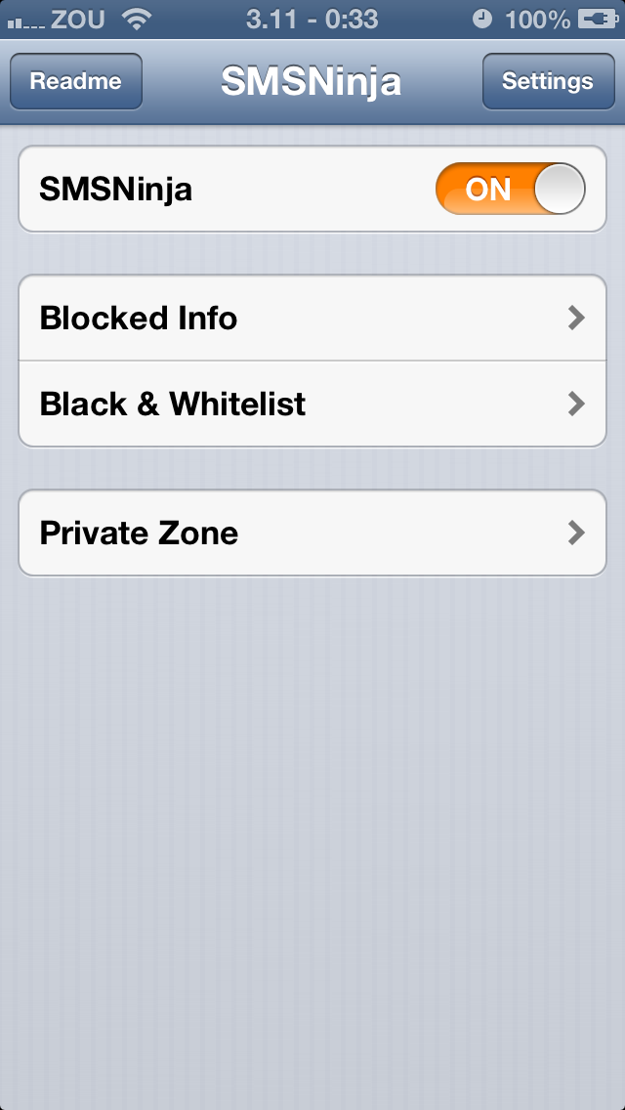
- Global variables:
UISwitch *appSwitch: Corresponds to appIsOn
NSNumber *fake: A bool value indicates whether to show a fake SMSNinja UI. Initialized in SMSNinjaApplication.mm
- SettingsViewController
- UI draft:
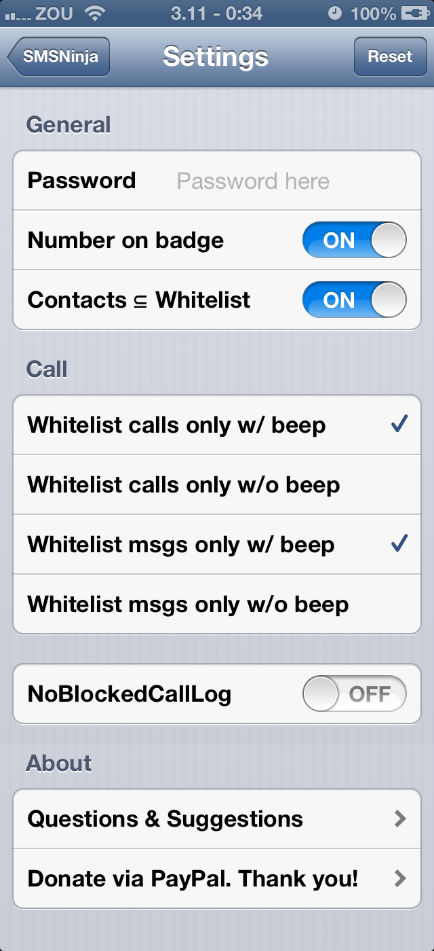
- Global variables:
UISwitch *badgeSwitch: Corresponds to shouldShowBadge
UISwitch *clearSwitch: Corresponds to shouldClearSpam
UISwitch *addressbookSwitch: Corresponds to shouldIncludeContactsInWhitelist
- ReadMeViewController
- UI draft:
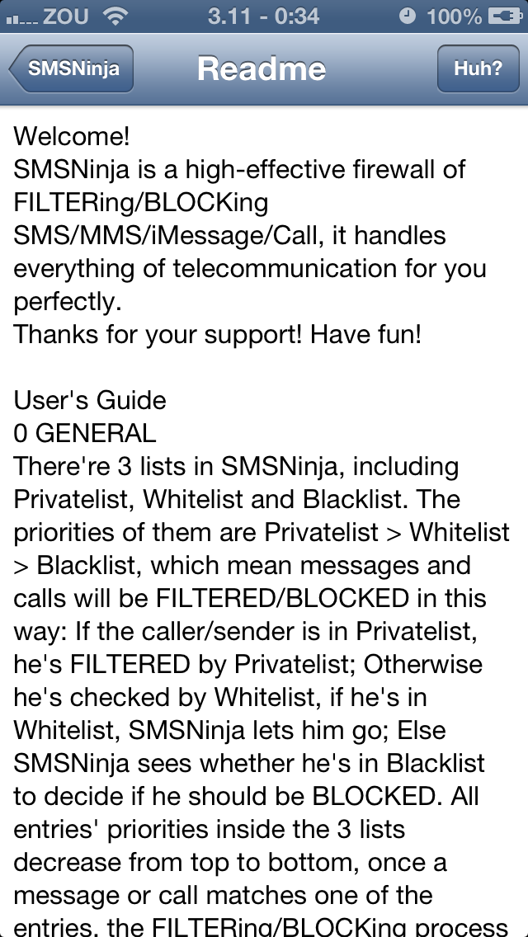
- Global variables:
NSNumber *fake: A bool value indicates whether to show a fake SMSNinja UI. Initialized in RootViewController.mm
- SMSHistoryViewController
- UI draft:
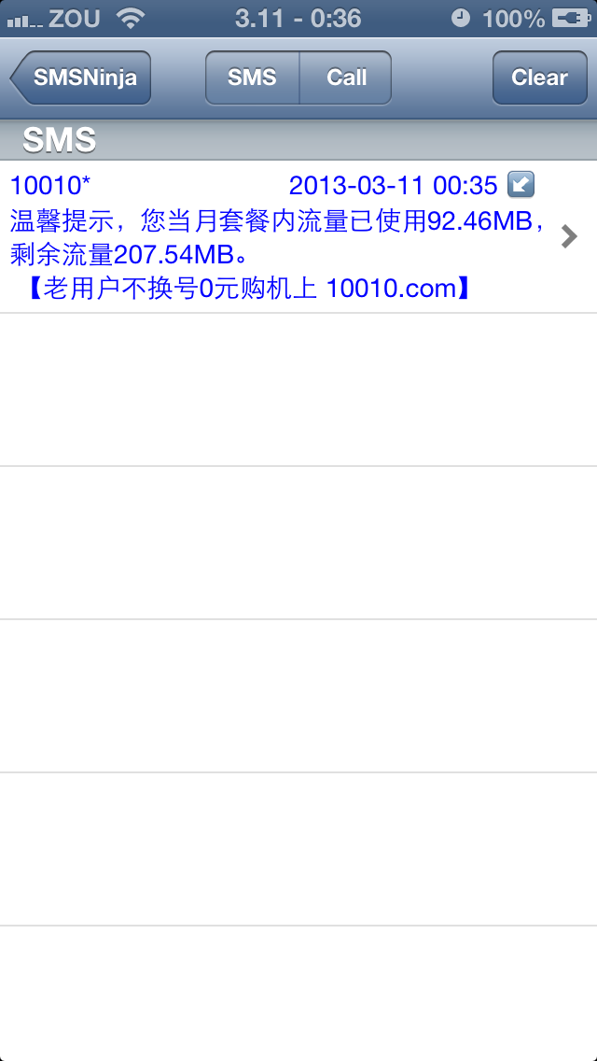
- Global variables:
NSMutableArray *idArray: Stores all ids of blockedsms
NSMutableArray *nameArray: Stores all names of blockedsms
NSMutableArray *numberArray: Stores all addresses of blockedsms
NSMutableArray *contentArray: Stores all message bodies of blockedsms
NSMutableArray *timeArray: Stores all times of blockedsms
NSMutableArray *readArray: Stores all read statuses of blockedsms
NSMutableArray *picturesArray: Store all picture numbers of blockedsms
int chosenRow: Chosen address, used by @tel and @sms
- CallHistoryViewController
- UI draft:
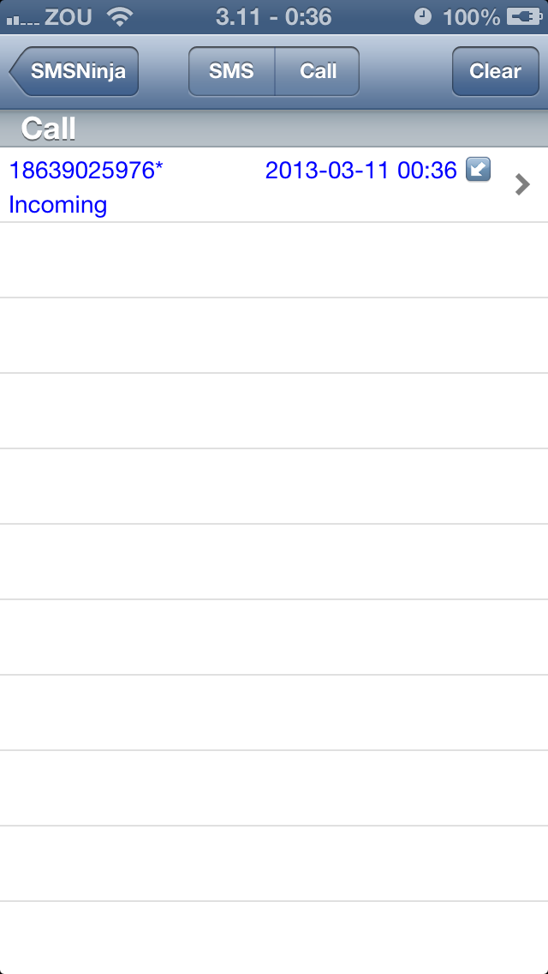
- Global variables:
NSMutableArray *idArray: Stores all ids of blockedcall
NSMutableArray *nameArray: Stores all names of blockedcall
NSMutableArray *numberArray: Stores all addresses of blockedcall
NSMutableArray *contentArray: Stores all message bodies of blockedcall
NSMutableArray *timeArray: Stores all times of blockedcall
NSMutableArray *readArray: Stores all read statuses of blockedcall
int chosenRow: Chosen address, used by @tel and @sms
- BlacklistViewController
- UI draft:
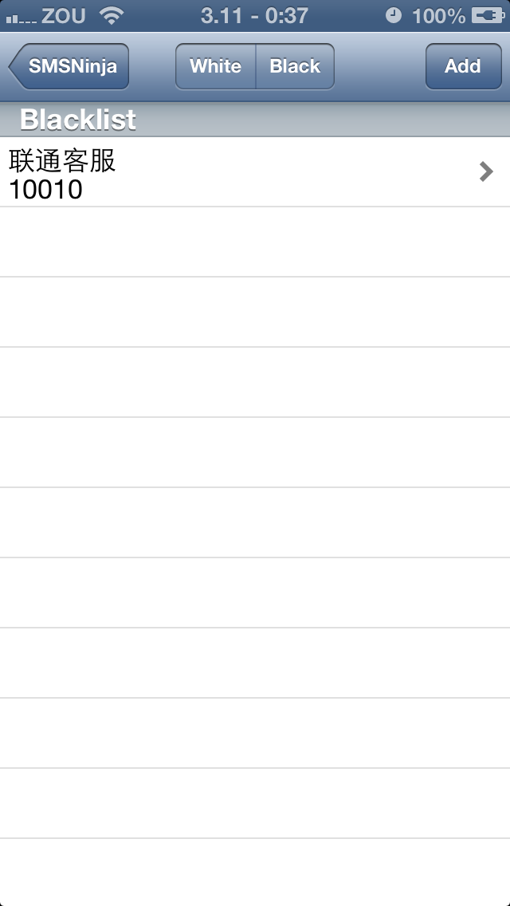
- Global variables:
NSMutableArray *keywordArray: Stores all keywords of blacklist
NSMutableArray *typeArray: Stores all types of blacklist
NSMutableArray *nameArray: Stores all names of blacklist
NSMutableArray *phoneArray: Stores all phones of blacklist
NSMutableArray *smsArray: Stores all smses of blacklist
NSMutableArray *replyArray: Stores all replies of blacklist
NSMutableArray *messageArray: Stores all reply messages of blacklist
NSMutableArray *forwardArray: Stores all forwards of blacklist
NSMutableArray *numberArray: Stores all forward numbers of blacklist
NSMutableArray *soundArray: Stores all sounds of blacklist
- WhitelistViewController
- UI draft:
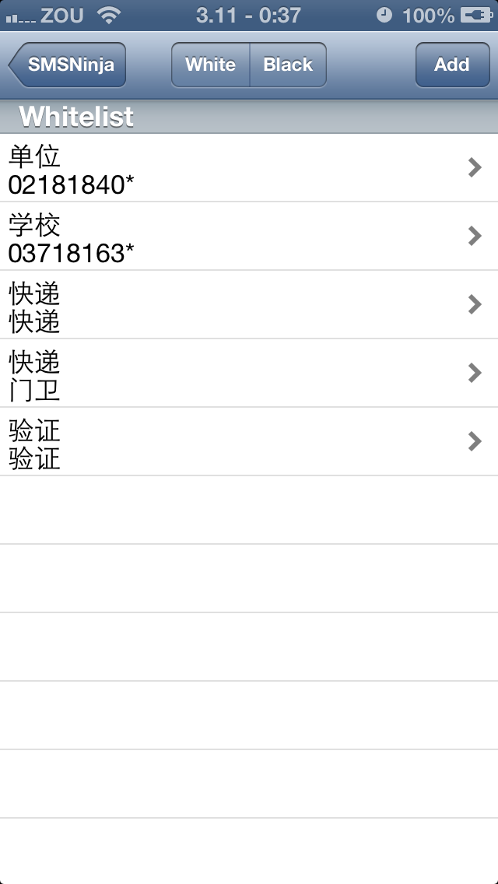
- Global variables:
NSMutableArray *keywordArray: Stores all keywords of whitelist
NSMutableArray *typeArray: Stores all types of whitelist
NSMutableArray *nameArray: Stores all names of whitelist
- ContactLogViewController
- UI draft:
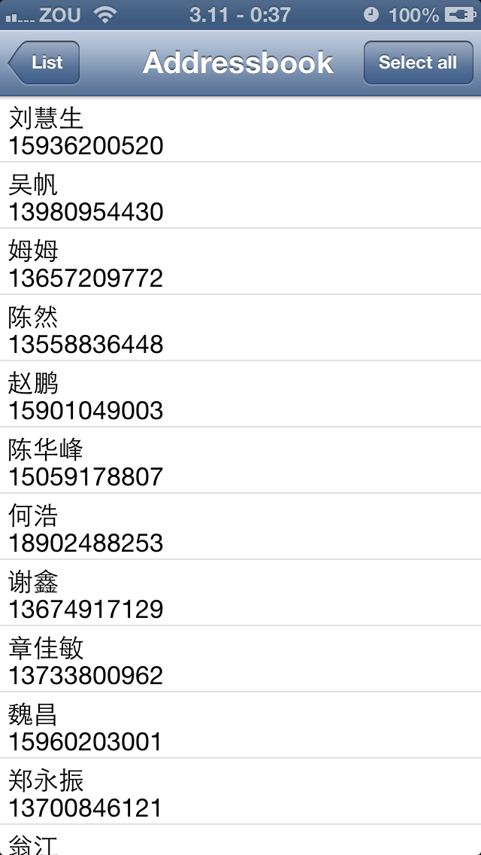
- Global variables:
NSMutableArray *numberArray: Stores all numbers of AddressBook.sqlitedb
NSMutableArray *nameArray: Stores all names of AddressBook.sqlitedb
NSMutableArray *idArray: Stores all ids of AddressBook.sqlitedb
NSString *chosenNumber: Chosen number, used to insert into smsninja.db
NSString *chosenName: Chosen name, used to insert into smsninja.db
NSString *flag: Indicate the caller of this controller, @”black” or @”white” or @“private”
- CallLogViewController
- UI draft:
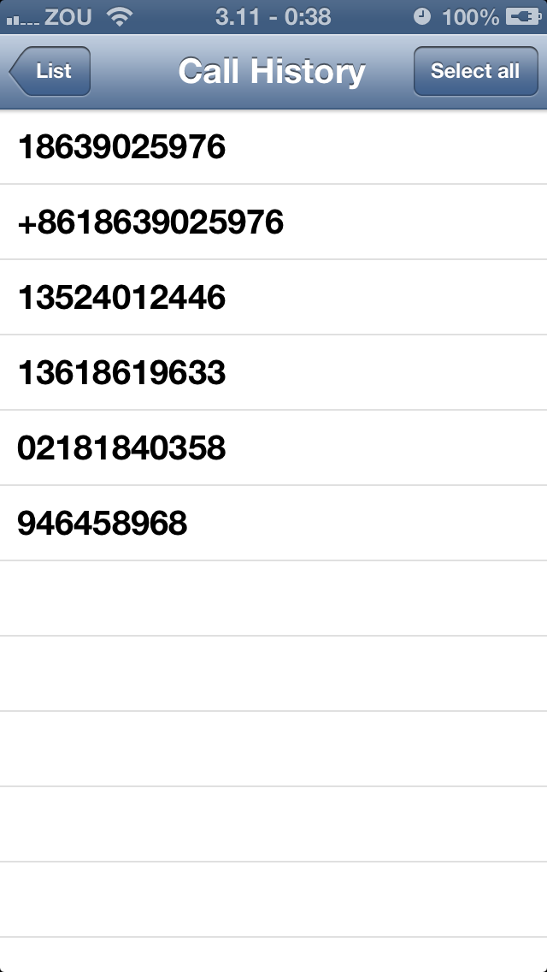
- Global variables:
NSMutableArray *numberArray: Stores all numbers of call_history.db
NSString *chosenNumber: Chosen number, used to insert into smsninja.db
NSString *flag: Indicate the caller of this controller, @”black” or @”white” or @“private”
- SMSLogViewController
- UI draft:
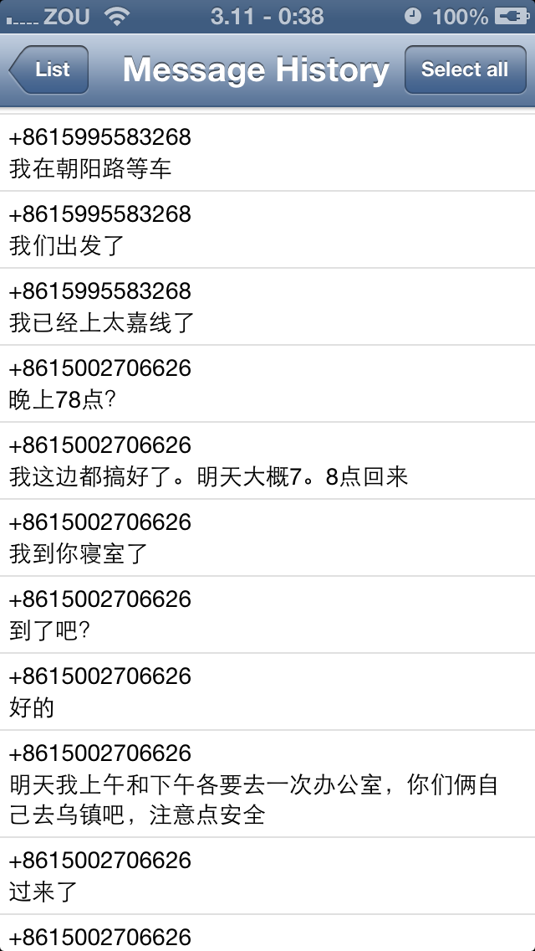
- Global variables:
NSMutableArray *numberArray: Stores all numbers of sms.db
NSMutableArray *textArray: Stores all texts of sms.db
NSString *chosenNumber: Chosen number, used to insert into smsninja.db
NSString *flag: Indicate the caller of this controller, @”black” or @”white” or @“private”
- TimeViewController
- UI draft:
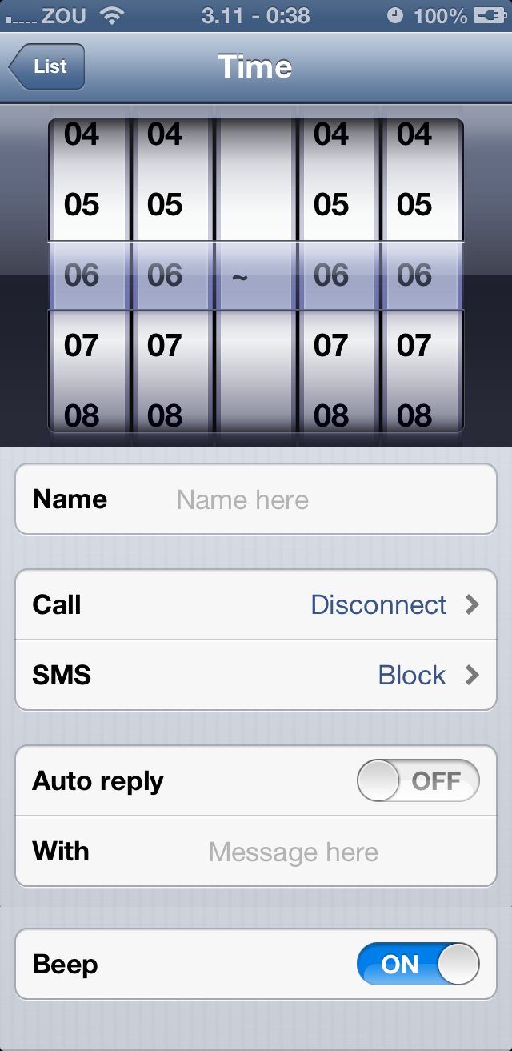
- Global variables:
UIPickerView *timePickerView: Time wheel
UITableView *configTableView: Configuration table
/* For UI initialization, determined by caller */
NSString *nameString: Name
NSString *keywordString: Time, e.g. @”06:06~06:06”
NSString *phoneString: 0 for off, 1 for disconnect, 2 for ignore
NSString *smsString: 0 for off, 1 for block
NSString *replyString: 0 for off, 1 for on
NSString *messageString: Reply message
NSString *forwardString: 0 for off, 1 for on
NSString *numberString: Forward number
NSString *soundString: 0 for off, 1 for on
/* For database insert operation */
UITextField *nameField: Corresponds to name
UISwitch *replySwitch: Corresponds to reply
UITextField *replyField: Corresponds to message
UISwitch *soundSwitch: Corresponds to sound
*/
- NumberViewController
- UI draft:
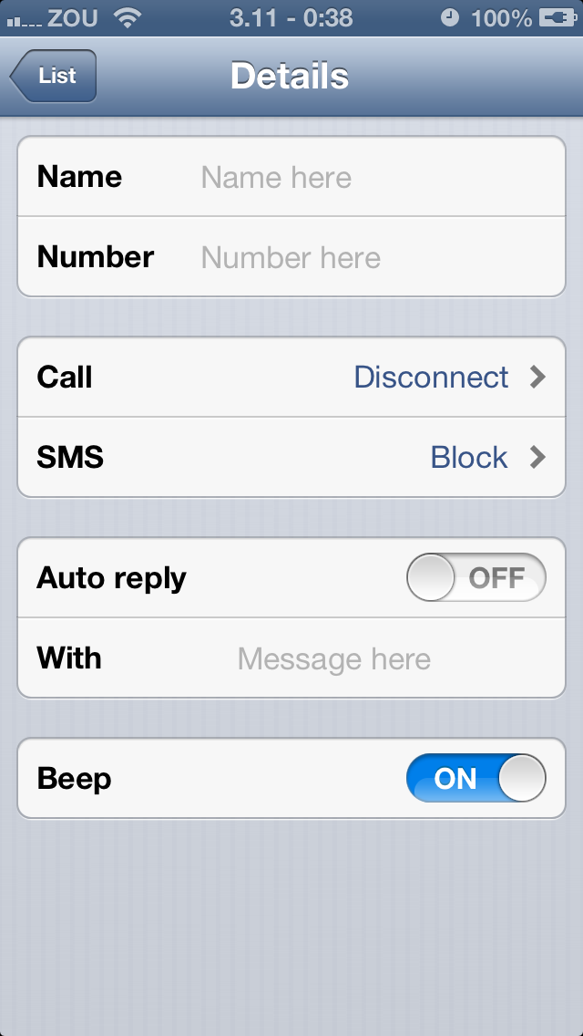
- Global variables:
/* For UI initialization, determined by caller */
NSString *nameString: Name
NSString *keywordString: Address
NSString *phoneString: 0 for off, 1 for disconnect, 2 for ignore, 3 for let go (private zone only)
NSString *smsString: 0 for off, 1 for block
NSString *replyString: 0 for off, 1 for on
NSString *messageString: Reply message
NSString *forwardString: 0 for off, 1 for on
NSString *numberString: Forward number
NSString *soundString: 0 for off, 1 for on
NSString *flag: Indicate the caller of this controller, @”black” or @”white” or @“private”
/* For database insert operation */
NSMutableArray *keywordArray: Stores multiple addresses for insert operation
UITextField *nameField: Corresponds to name
UITextField *numberField: Corresponds to address
UISwitch *replySwitch: Corresponds to reply
UITextField *replyField: Corresponds to message
UISwitch *soundSwitch: Corresponds to sound
- ContentViewController
- UI draft:
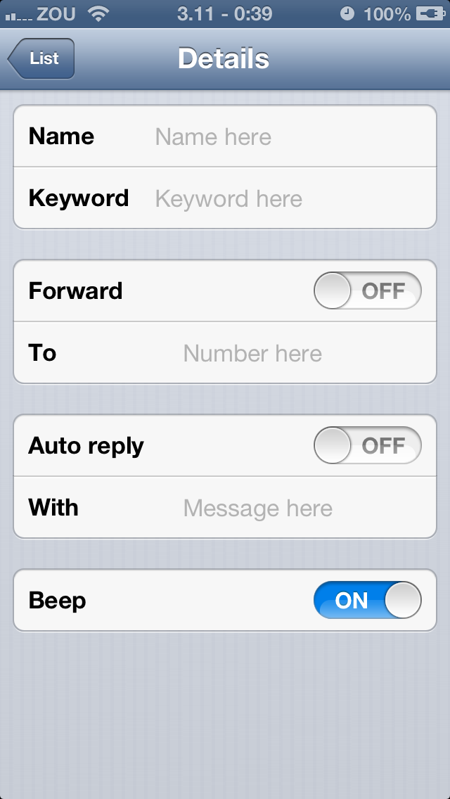
- Global variables:
/* For UI initialization, determined by caller */
NSString *nameString: Name
NSString *keywordString: Keyword
NSString *replyString: 0 for off, 1 for on
NSString *messageString: Reply message
NSString *forwardString: 0 for off, 1 for on
NSString *numberString: Forward number
NSString *soundString: 0 for off, 1 for on
NSString *flag: Indicate the caller of this controller, @”black” or @”white”
/* For database insert operation */
NSMutableArray *keywordArray: Stores multiple keywords for insert operation
UITextField *nameField: Corresponds to name
UITextField *numberField: Corresponds to address
UISwitch *replySwitch: Corresponds to reply
UITextField *replyField: Corresponds to message
UISwitch *forwardSwitch: Corresponds to forward
UITextField *forwardField: Corresponds to number
UISwitch *soundSwitch: Corresponds to sound
- PrivateViewController
- UI draft:
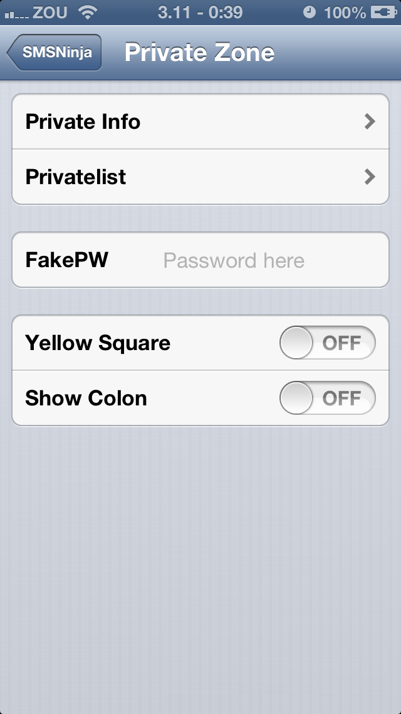
- Global variables:
UISwitch *yellowSwitch: Corresponds to shouldShowYellowSquare
UISwitch *colonSwitch: Corresponds to shouldShowColon
- PrivateSMSHistoryViewController
- UI draft:
Similar to SMSHistoryViewController
- Global variables:
NSMutableArray *idArray: Stores all ids of privatesms
NSMutableArray *nameArray: Stores all names of privatesms
NSMutableArray *numberArray: Stores all addresses of privatesms
NSMutableArray *contentArray: Stores all message bodies of privatesms
NSMutableArray *timeArray: Stores all times of privatesms
NSMutableArray *picturesArray: Store all picture numbers of privatesms
int chosenRow: Chosen address, used by @tel and @sms
- PrivateCallHistoryViewController
- UI draft:
Similar to CallHistoryViewController
- Global variables:
NSMutableArray *idArray: Stores all ids of privatecall
NSMutableArray *nameArray: Stores all names of privatecall
NSMutableArray *numberArray: Stores all addresses of privatecall
NSMutableArray *contentArray: Stores all message bodies of privatecall
NSMutableArray *timeArray: Stores all times of privatecall
int chosenRow: Chosen address, used by @tel and @sms
- PrivateListViewController
- UI draft:
Similar to BlacklistViewController
- Global variables:
NSMutableArray *keywordArray: Stores all keywords of privatelist
NSMutableArray *typeArray: Stores all types of privatelist
NSMutableArray *nameArray: Stores all names of privatelist
NSMutableArray *phoneArray: Stores all phones of privatelist
NSMutableArray *smsArray: Stores all smses of privatelist
NSMutableArray *replyArray: Stores all replies of privatelist
NSMutableArray *messageArray: Stores all reply messages of privatelist
NSMutableArray *forwardArray: Stores all forwards of privatelist
NSMutableArray *numberArray: Stores all forward numbers of privatelist
NSMutableArray *soundArray: Stores all sounds of privatelist
- CallDetailSettingsViewController
- UI draft:
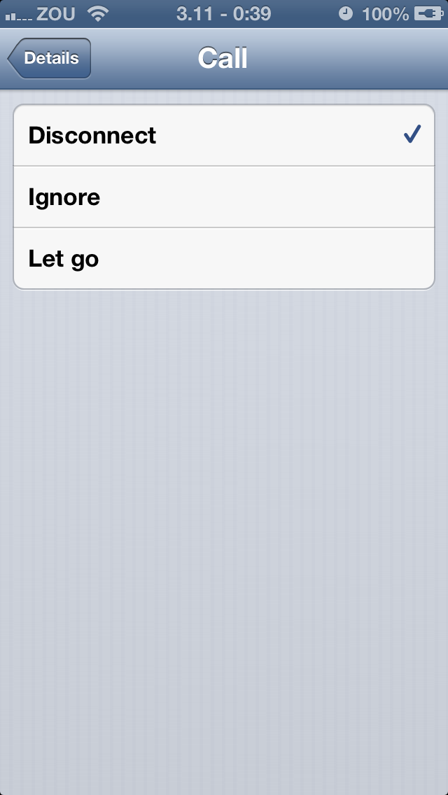
- Global variables:
NSString *phoneString: 0 for off, 1 for disconnect, 2 for ignore, 3 for let go (private zone only)
NSString *flag: Indicate the caller of this controller, @”black” or @“private”
- SMSDetailSettingsViewController
- UI draft:
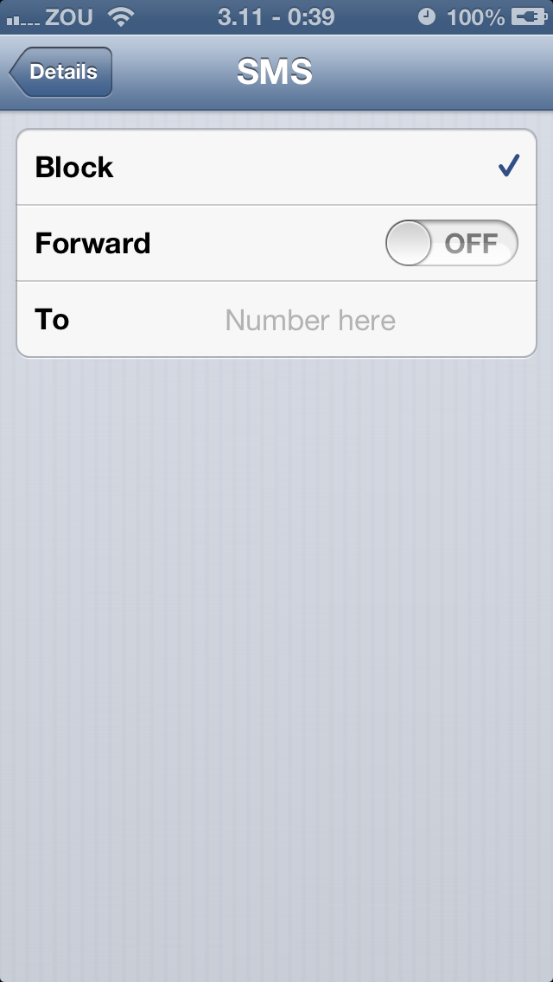
- Global variables:
NSString *smsString: 0 for off, 1 for block
NSString *forwardString: 0 for off, 1 for on
NSString *numberString: Forward number
UISwitch *forwardSwitch: Corresponds to forward
UITextField *forwardField: Corresponds to number
- PictureViewController
- UI draft:

- Global variables:
NSString * idString: id of the selected messge
NSString * flag: Indicate the caller of this controller, @”black” or @“private”
int picturesCount: How many pictures are there in this message, used to stick these pictures

